Sana Khan

Lab_04

Case Study 1:

No Deliverable

Case Study 2:

OrderItem(*Order Num,* Line, Item Number, Description, Qty Ordered, Price Each)

3NF:

OrderItem(*Order Num,* Line, Item Number, Qty Ordered)

Item( *Item Number,* Description, Price Each)

Case Study 3:

1.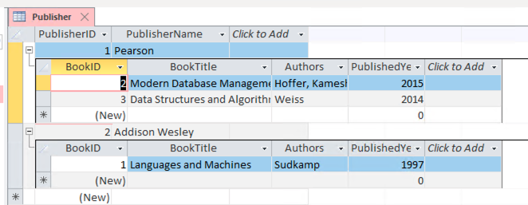

2. No this is not in 3NF. For it to be in 3NF it would first need to be 1NF which is where we break out any multivalued attributes into their own row/column. Then we would need to put it into 2NF which resolves all partial functional dependencies. To be in 3NF we would then need to remove any transitive functional dependencies.

Case Study 4:

Start:

Video (VideoID, Video Title, User Name, User Tier, Min Tier Followers, Stream Start, Video Duration(mins), Content Rating, Rating Description)

3NF:

Video(*VideoID*, User Name)

VideoContent(*VideoID,* Stream Start, Video Duration(mins), Content Rating)

User(*User Name*,User Tier, Min Tier Followers)

ContentRating(*Content Rating*, Rating Description)